A

Mini Project On

#### FIGHTING AND GUNPOINT DETECTION

(Submitted in partial fulfillment of the requirements for the award of Degree)

BACHELOR OF TECHNOLOGY

In

COMPUTER SCIENCE AND ENGINEERING

By

MAMIDIPALLY RISHITHA REDDY (207R1A0595)

GUGLAVATH SRISHANTH (207R1A0580)

MARIPEDDA PRAVEEN (217R5A0508)

Under the Guidance of

**Ms. SABA SULTANA**

(Assistant Professor)

##### DEPARTMENT OF COMPUTER SCIENCE AND ENGINEERING

**CMR TECHNICAL CAMPUS UGC AUTONOMOUS**

(Accredited by NAAC, NBA, Permanently Affiliated to JNTUH, Approved by AICTE, New Delhi) Recognized Under Section 2(f) & 12(B) of the UGCAct.1956, Kandlakoya (V), Medchal Road, Hyderabad-501401.

**2020-2024**

**DEPARTMENT OF COMPUTER SCIENCE AND ENGINEERING**



#### CERTIFICATE

This is to certify that the project entitled **“FIGHTING AND GUNPOINT DETECTION”** being submitted by **M. RISHITHA REDDY (207R1A0595), GUGLAVANTH SRISHANTH (207R1A0580) & MARIPEDDA PRAVEEN (217R5A0508)** in partial fulfillment of the requirements for the award of the degree of B.Tech in Computer Science and Engineering to the Jawaharlal Nehru Technological University Hyderabad, is a record of bonafide work carried out by them under our guidance and supervision during the year 2023-24.

The results embodied in this thesis have not been submitted to any other University or Institute for the award of any degree or diploma.

**Ms. Saba Sultana Dr. A. Raji Reddy**

(Assistant Professor) DIRECTOR

INTERNAL GUIDE

**Dr. K. Srujan Raju EXTERNAL EXAMINER**

HOD

**Submitted for viva voice Examination held on**

##### ACKNOWLEDGEMENT

Apart from the efforts of us, the success of any project depends largely on the encouragement and guidelines of many others. We take this opportunity to express our gratitude to the people who have been instrumental in the successful completion of this project.

We take this opportunity to express my profound gratitude and deep regard to my guide **Ms.Saba Sultana,** Assistant Professor for her exemplary guidance, monitoring and constant encouragement throughout the project work. The blessing, help and guidance given by her shall carry us a long way in the journey of life on which we are about to embark.

We also take this opportunity to express a deep sense of gratitude to the Project Review Committee (PRC) **G.Vinesh Shanker, Dr. J. Narasimharao, Ms. Shilpa, & Dr. K. Maheswari** for their cordial support, valuable information and guidance, which helped us in completing this task through various stages.

We are also thankful to **Dr. K. Srujan Raju,** Head, Department of Computer Science and Engineering for providing encouragement and support for completing this project successfully.

We are obliged to **Dr. A. Raji Reddy,** Director for being cooperative throughout the course of this project. We also express our sincere gratitude to Sri. **Ch. Gopal Reddy,** Chairman for providing excellent infrastructure and a nice atmosphere throughout the course of this project.

The guidance and support received from all the members of **CMR Technical Campus** who contributed to the completion of the project. We are grateful for their constant support and help.

Finally, we would like to take this opportunity to thank our family for their constant encouragement, without which this assignment would not be completed. We sincerely acknowledge and thank all those who gave support directly and indirectly in the completion of this project.

###### M. RISHITHA REDDY (207R1A0595)

**GUGLAVATH SRISHANTH (207R1A0580)**

**MARIPEDDA PRAVEEN (217R5A0508)**

##### ABSTRACT

Motion detection is the process of detecting a change in the position of an object relative to its surroundings or a change in the surroundings relative to an object. Object detection is a computer technology related to computer vision and image processing that deals with detecting instances of semantic objects of a certain class (such as humans, buildings, or cars) in digital images and videos. Human motion gesture recognition is the most challenging research direction in the field of computer vision, and it is widely used in human-computer interaction, intelligent monitoring, virtual reality, human behavior analysis, and other fields. Now-a-days, surveillance videos are able to capture a variety of realistic anomalies. This model can detect the fighting behavior and weapons shown on the camera with a simple message. This can be done with the help of the training that the model will receive from the training data set.

The message would be a simple prompt like “weapon detected in the frame’s message based on particular images recognized. In this project we tend to implement this in enhancing safety, security and public well-being. The system would be promoting or giving out a message for every fighting behavior or detection of weapons. This project would be an extension to the motion and object recognition system. The model would be trained with enormous dataset so that the accuracy level is maintained in correct prediction.

|  |  |  |
| --- | --- | --- |
| **FIGURE NO** | **FIGURE NAME** | **PAGE NO** |
| Figure 3.1 | Project Architecture for Fighting and Gunpoint Detection | 14 |
| Figure 3.2 | Use Case Diagram for Fighting and Gunpoint Detection | 16 |
| Figure 3.3 | Class Diagram for Fighting and Gunpoint Detection | 17 |
| Figure 3.4 | Sequence diagram for Fighting and Gunpoint Detection | 18 |
| Figure 3.5 | Activity diagram for Fighting and Gunpoint Detection | 19 |

|  |  |  |
| --- | --- | --- |
| **SCREENSHOT NO.** | **SCREENSHOT NAME** | **PAGE NO**. |
| Screenshot 5.1  Screenshot 5.2 | Weapon Recognized  Weapon Recognized | 25  25 |
| Screenshot 5.3 | Recognised and Displayed With a Message | 26 |
| Screenshot 5.4 | Screen Display | 27 |
|  |  |  |
|  |  |  |

###### ABSTRACT i

LIST OF FIGURES ii

LIST OF SCREENSHOTS iii

1. INTRODUCTION 1

PROJECT SCOPE 2

PROJECT PURPOSE 2

PROJECT FEATURES 3

1. SYSTEM ANALYSIS 4

PROBLEM DEFINITION 5

EXISTING SYSTEM 6

DISADVANTAGES OF THE EXISTING SYSTEM 7

PROPOSED SYSTEM 7

ADVANTAGES OF PROPOSED SYSTEM 8

FEASIBILITY STUDY 9

ECONOMIC FEASIBILITY 9

TECHNICAL FEASIBILITY 10

BEHAVIORAL FEASIBILITY 10

HARDWARE & SOFTWARE REQUIREMENTS 11

HARDWARE REQUIREMENTS 11

SOFTWARE REQUIREMENTS 12

1. ARCHITECTURE 13

PROJECT ARCHITECTURE 14

DESCRIPTION 15

USE CASE DIAGRAM 16

CLASS DIAGRAM 17

SEQUENCE DIAGRAM 18

ACTIVITY DIAGRAM 19

1. IMPLEMENTATION 20

SAMPLE CODE 21

1. SCREENSHOTS 24
2. TESTING 28

INTRODUCTION TO TESTING 29

TYPES OF TESTING 29

UNIT TESTING 29

INTEGRATION TESTING 30

FUNCTIONAL TESTING 30

TEST CASES 31

CLASSIFICATION 31

1. CONCLUSION & FUTURE SCOPE 32

PROJECT CONCLUSION 33

FUTURE SCOPE 33

1. BIBLIOGRAPHY 34

REFERENCES 35

GITHUB LINK 35

# INTRODUCTION

1

#### INTRODUCTION

##### PROJECT SCOPE

This project is titled “Fighting and Gunpoint Detection. The scope of a project focused on fighting and gunpoint detection encompasses various aspects, from defining the objectives and deliverables to outlining the technologies and methodologies to be employed. The scope of a fighting and gunpoint detection project is extensive and requires a multidisciplinary approach involving computer vision, deep learning, privacy considerations, and real-time processing. The scope of a project focused on fighting and gunpoint detection encompasses various aspects, from defining the objectives and deliverables to outlining the technologies and methodologies to be employed. The scope of a fighting and gunpoint detection project is extensive and requires a multidisciplinary approach involving computer vision, deep learning, privacy considerations, and real-time processing.

##### PROJECT PURPOSE

The primary purpose of the system is to perform anomaly detection in video data. Anomalies represent unusual or unexpected events or behaviors that deviate from typical or normal patterns. The system contributes to the research community by introducing a large-scale video anomaly detection dataset. This dataset is substantial, consisting of 1900 real-world surveillance videos. The dataset also serves as a benchmark for activity recognition in untrimmed videos. Results from baseline methods are provided for recognizing 13 different anomalous activities within the dataset.

##### 

2

##### PROJECT FEATURES

##### The proposed system incorporates several key features designed to enhance its effectiveness in video anomaly detection and activity recognition. It leverages Multiple Instance Learning (MIL) to handle weakly labeled training data, allowing it to identify anomalies without detailed segment-level annotations. The system's deep learning network employs a MIL ranking loss with sparsity and smoothness constraints to improve anomaly score estimation for video segments, enhancing accuracy and reducing false positives. Furthermore, the introduction of a substantial large-scale video anomaly detection dataset, containing 1900 real-world surveillance videos capturing diverse anomalous events, provides ample training and evaluation data. This dataset also doubles as a challenging benchmark for activity recognition in untrimmed videos, reflecting real-world complexities.

3

## 2.SYSTEM ANALYSIS

4

3

##### SYSTEM ANALYSIS

System analysis is a crucial phase in the lifecycle of a project or system

development process. It involves a comprehensive examination and evaluation of

various aspects of a system to understand its requirements, functionalities, limitations,

and potential improvements. This systematic process aims to ensure that the system

aligns with the project's objectives and meets the needs of its intended users. Once

analysis is completed the analyst has a firm understanding of what is to be done.

Overall, system analysis is a critical phase in project development, as it lays the

foundation for system design, development, and implementation. It helps ensure that the

final system aligns with the project's objectives, functions effectively, and meets the

needs of its users.

##### PROBLEM DEFINITION

A general statement of violent behavior and gun detection can be formulated as to revolutionize video analysis by developing an advanced system for anomaly detection and activity recognition in surveillance videos. Leveraging the power of Multiple Instance Learning (MIL), our innovative approach allows us to detect anomalies within video segments, even with limited labeled training data.

.

##### 

5

##### EXISTING SYSTEM

In the existing system, the success of sparse representation and dictionary learning approaches in several computer vision problems, researchers used sparse representation to learn the dictionary of normal behaviors. During testing, the patterns which have large reconstruction errors are considered as anomalous behaviors. Due to successful demonstration of deep learning for image classification, several approaches have been proposed for video action classification. However, obtaining annotations for training is difficult and laborious, specifically for videos. Recently, it used deep learning based auto encoders to learn the model of normal behaviors and employed reconstruction loss to detect anomalies. Our approach not only considers normal behaviors but also anomalous behaviors for anomaly detection, using only weakly labeled training data.

..

6

5

###### DISADVANTAGES OF EXISTING SYSTEM

Following are the disadvantages of existing system:

* The system's reliance on manually defined normal behaviors limit its ability to generalize to new and unexpected anomalies.
* Sensitivity to Dictionary Quality
* Limited Automation
* Difficulty in Scalability

##### PROPOSED SYSTEM

In this project, we propose a MIL solution to anomaly detection by leveraging only weakly labeled training videos. We pro- pose a MIL ranking loss with sparsity and smoothness constraints for a deep learning network to learn anomaly scores for video segments. We introduce a large-scale video anomaly detection dataset consisting of 1900 real-world surveillance videos of 13 different anomalous events and normal activities captured by surveillance cameras. It is by far the largest dataset with more than 25 times videos than existing largest anomaly dataset and has a total of 128 hours of videos. Experimental results on our new dataset show that our proposed method achieves superior performance as com- pared to the state-of-the-art anomaly detection approaches. Our dataset also serves a challenging benchmark for activity recognition on untrimmed videos, due to the complexity of activities and large intra-class variations. We provide results of baseline methods, C3D [37] and TCNN [21], on recognizing 13 different anomalous activities

7

###### ADVANTAGES OF THE PROPOSED SYSTEM

* Large Scale Dataset
* Diverse **Anomalous Events**
* Effective Anomaly Detection
* Potential for Generalization
* Applicability to Real-World Scenarios

8

7

##### FEASIBILITY STUDY

The feasibility of the project is analyzed in this phase and a business proposal is put forth with a very general plan for the project and some cost estimates. During system analysis the feasibility study of the proposed system is to be carried out. This is to ensure that the proposed system is not a burden to the company. Three key considerations involved in the feasibility analysis:

* Economic Feasibility
* Technical Feasibility
* Social Feasibility

###### ECONOMIC FEASIBILITY

The developing system must be justified by cost and benefit. Criteria to ensure that effort is concentrated on a project, which will give best, return at the earliest. One of the factors, which affect the development of a new system, is the cost it would require.

The following are some of the important financial questions asked during preliminary investigation:

* The costs conduct a full system investigation.
* The cost of the hardware and software.
* The benefits in the form of reduced costs or fewer costly errors.

Since the system is developed as part of project work, there is no manual cost to spend for the proposed system. Also all the resources are already available, it give an indication that the system is economically possible for development.

9

8

###### 

###### TECHNICAL FEASIBILITY

This study is carried out to check the technical feasibility, that is, the technical requirements of the system. Any system developed must not have a high demand on the available technical resources. The developed system must have a modest requirement, as only minimal or null changes are required for implementing this system.

###### BEHAVIORAL FEASIBILITY

This includes the following questions:

* Is there sufficient support for the users?
* Will the proposed system cause harm?

The project would be beneficial because it satisfies the objectives when developed and installed. All behavioral aspects are considered carefully and conclude that the project is behaviorally feasible

##### 

10

##### HARDWARE & SOFTWARE REQUIREMENTS

###### HARDWARE REQUIREMENTS:

Hardware interfaces specify the logical characteristics of each interface between the software product and the hardware components of the system. The following are some hardware requirements.

* **System :** Pentium IV 2.4GHz.
* **Hard Disk :** 40 GB.
* **Floppy Drive :** 1.44 Mb.
* **RAM :** 512 Mb.
* **Monitor** : 14’ Colour Monitor.

11

##### 

##### SOFTWARE REQUIREMENTS:

Software Requirements specifies the logical characteristics of each interface and software components of the system. The following are some software requirements,

* **Operating system :** Windows 7 Ultimate.
* **Coding Language :** Python.
* **Front-End :** Python.
* **Designing :** HTML, CSS, Javascript.
* **Data Base :** MySQL.

12

10

## ARCHITECTURE

13

##### 3. PROJECT ARCHITECTURE

This project architecture shows the procedure followed for classification, starting from input to final prediction.

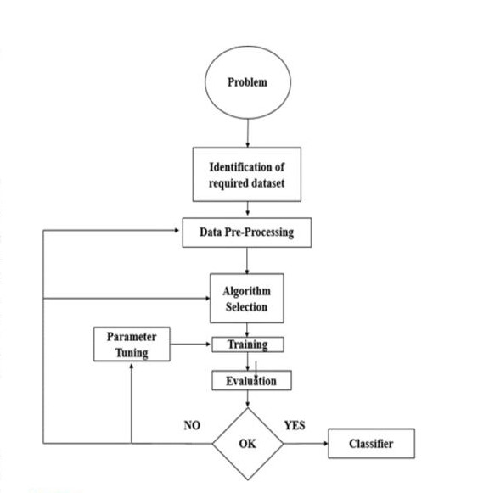

Figure 3.1: Project Architecture of Fighting and Gunpoint Detection

14

###### 

###### DESCRIPTION

To create a real-time weapon detection system for CCTV videos using deep learning, we employ a Convolutional Neural Network (CNN) architecture. We start by collecting a diverse dataset of CCTV video footage, annotating frames containing weapons and fighting behavior. After preprocessing the data, we utilize a pre-trained CNN as the backbone, stripping the fully connected layers, and extract high-level features from the frames. A dedicated object detection head is added on top of the CNN to predict bounding boxes around potential weapons and fighting behavior. Training optimizes the network using loss functions and fine-tunes the pre-trained layers. For real-time inference, the model is deployed on suitable hardware, ensuring swift and accurate weapon and fighting detection in live CCTV video streams.

15

###### USE CASE DIAGRAM

In the use case diagram, we have basically one actor who is the user in the trained model.

A use case diagram is a graphical depiction of a user's possible interactions with a system. A use case diagram shows various use cases and different types of users the system has. The use cases are represented by either circles or ellipses. The actors are often shown as stick figures.



Figure 3.2: Use Case Diagram for Facial Recognition System With Voice Message Enhancement

16

##### CLASS DIAGRAM

Class diagram is a type of static structure diagram that describes the structure of a system by showing the system’s classes, their attributes, operations(or methods), and the relationships among objects.



Figure 3.3: Class Diagram for Facial Recognition System With Voice Message Enhancement

17

##### SEQUENCE DIAGRAM

A sequence diagram shows object interactions arranged in time sequence. It depicts the objects involved in the scenario and the sequence of messages exchanged between the objects needed to carry out the functionality of the scenario. Sequence diagrams are typically associated with use case realizations in the logical view of the system under development.



Figure 3.4: Sequence Diagram for Facial Recognition System With Voice Message Enhancement

18

###### ACTIVITY DIAGRAM

Activity diagrams are graphical representations of workflows of stepwise activities and actions with support for choice, iteration and concurrency. They can also include elements showing the flow of data between activities through one or more data stores.



Figure 3.5: Activity Diagram for Facial Recognition System With Voice Message Enhancement

19

## 4. IMPLEMENTATION

20

##### 4.1 SAMPLE CODE

pip install numpy==1.18.1

pip install matplotlib==3.1.3

pip install pandas==0.25.3

pip install opencv-python==4.2.0.32

pip install keras==2.3.1

pip install tensorflow==1.14.0

pip install h5py==2.10.0

pip install pillow==7.0.0

pip install sklearn-genetic==0.2

pip install SwarmPackagePy

pip install sklearn

pip install scikit-learn==0.22.2.post1

Pip install sklearn-extensions==0.0.2

Pip install pyswarms==1.1.0

pip install protobuf==3.20.0 --user

pip install urllib3==1.26.6

LogisticRegression(solver='liblinear')

pip install nltk

pip install django==2.1.7

pip install pymysql==0.9.3

21

pip install matplotlib==3.1.3 (used for display Graph)

pip install pandas==0.25.3 (Used to read dataset)

pip install opencv-python (used for image reading)

pip install keras==2.3.1 (used for neural Network Implementation)

pip install tensorflow==1.14.0 (used for CNN implementation)

pip install h5py==2.10.0 (used for support to tensorflow and keras libraries)

pip install sklearn (used for Machine learning Algorithms implementation like Decision tree,randomforest Tree,etc)

pip install --only-binary :all: mysqlclient --user

pip install mysqlclient --user

sc delete mysql

import pymysql

pymysql.install_as_MySQLdb()

predict = model.predict_classes(test)

pip install --user -U nltk

python

>>> import nltk

>>> nltk.download()

pip install -r requirements.txt

global filename

text.delete('1.0', END)

filename = filedialog.askopenfilename(initialdir="dataset")

dataset = pd.read_csv(filename)

22

,on_delete=models.CASCADE,

python -m pip install –-user -r requirements.txt

pip install urllib3==1.26.6

3.6.2 python

django==1.11.6

mysqlclient==1.3.12

## 

23

22

23

## 5.SCREENSHOTS

24

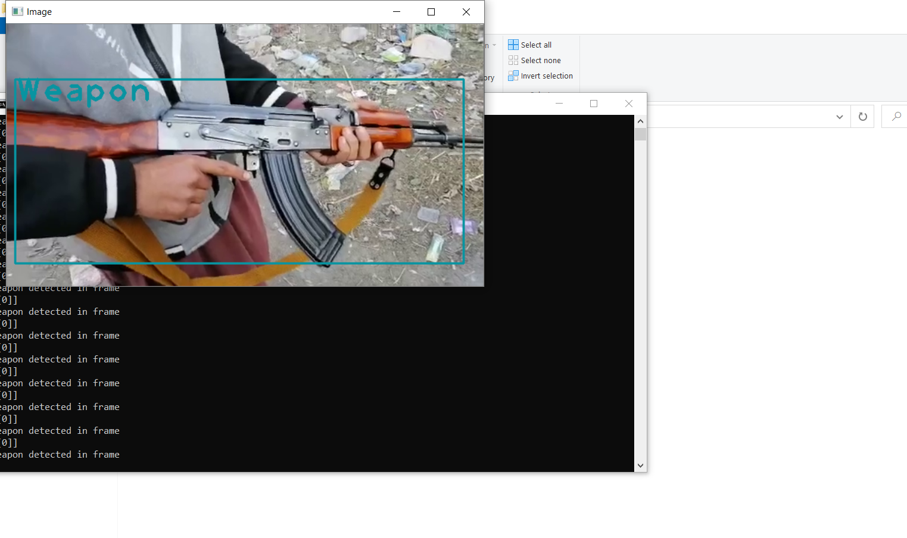

Screenshot 5.1: Weapon recognized

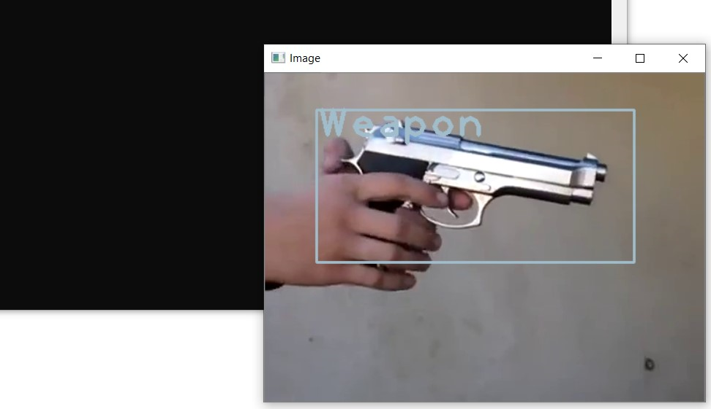

Screenshot 5.2: Weapon recognized

25

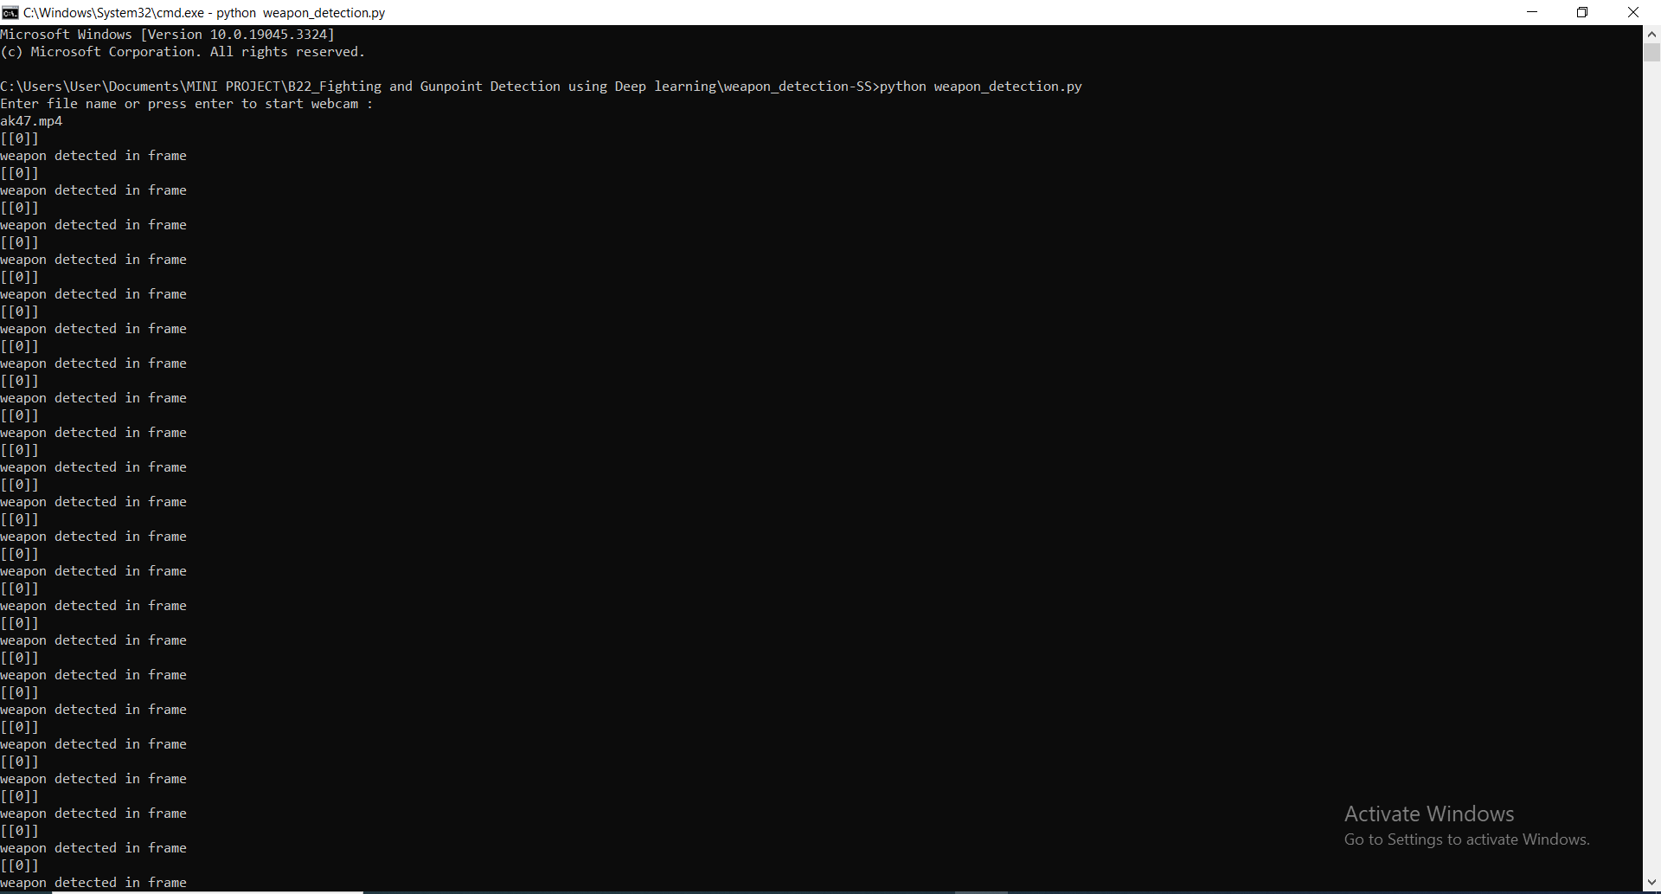

Screenshot 5.3: Weapon recognized and displayed with a message

26

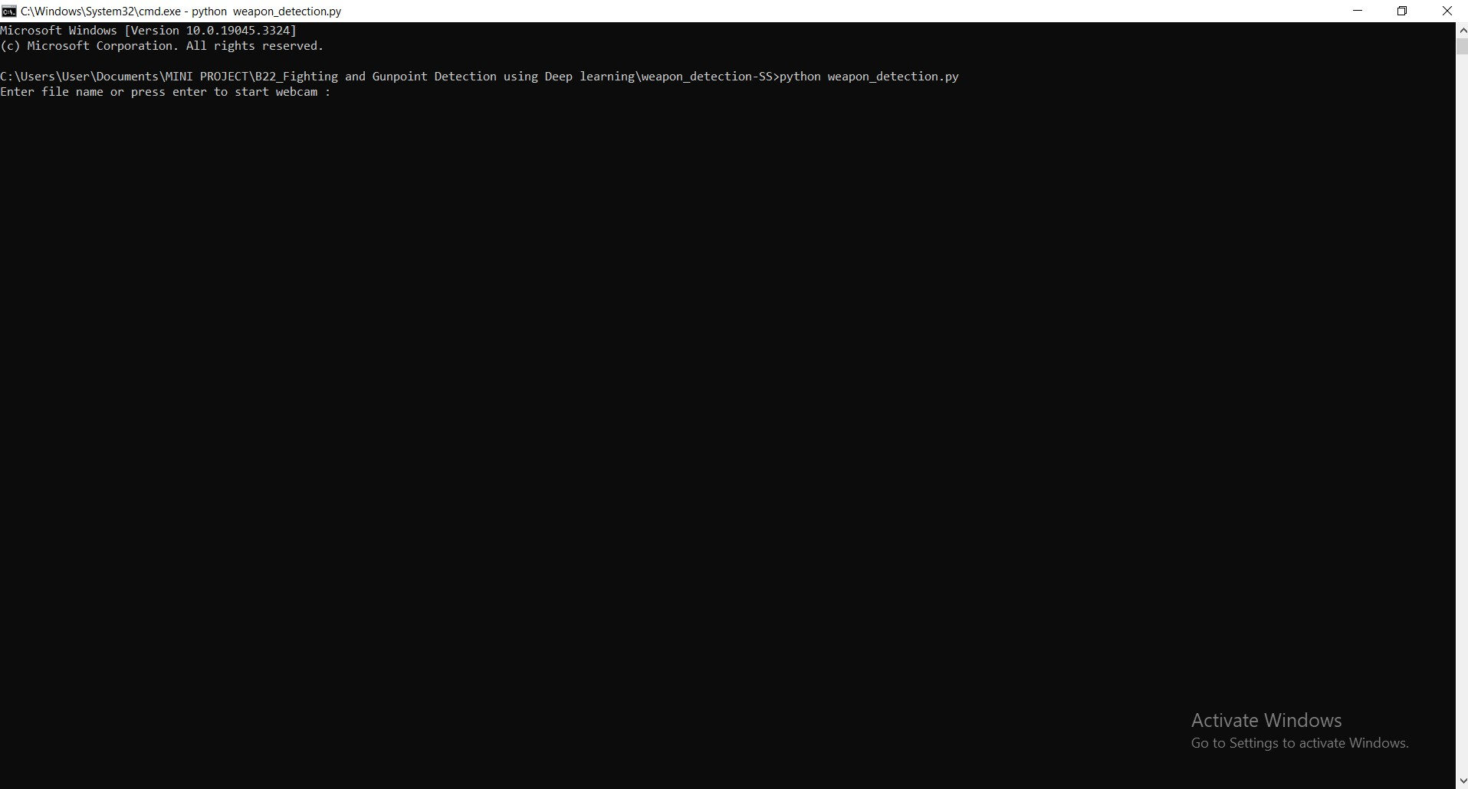

Screenshot 5.4: Screen Display

27

## TESTING

28

#### 6. TESTING

##### INTRODUCTION TO TESTING

The purpose of testing is to discover errors. Testing is the process of trying to discover every conceivable fault or weakness in a work product. It provides a way to check the functionality of components, subassemblies, assemblies and/or a finished product. It is the process of exercising software with the intent of ensuring that the Software system meets its requirements and user expectations and does not fail in an unacceptable manner. There are various types of tests. Each test type addresses a specific testing requirement.

##### TYPES OF TESTING

###### UNIT TESTING

Unit testing involves the design of test cases that validate that the internal program logic is functioning properly, and that program inputs produce valid outputs. All decision branches and internal code flow should be validated. It is the testing of individual software units of the application .It is done after the completion of an individual unit before integration. This is a structural testing that relies on knowledge of its construction and is invasive. Unit tests perform basic tests at component level and test a specific business process, application and/or system configuration. Unit tests ensure that each unique path of a business process performs accurately to the documented specifications and contains clearly defined inputs and expected results.

29

###### INTEGRATION TESTING

Integration tests are designed to test integrated software components to determine if they actually run as one program. Integration tests demonstrate that although the components were individually satisfactory, as shown by successfully unit testing, the combination of components is correct and consistent. Integration testing is specifically aimed at exposing the problems that arise from the combination of components.

###### FUNCTIONAL TESTING

Functional tests provide systematic demonstrations that functions tested are available as specified by the business and technical requirements, system documentation, and user manuals.

Functional testing is centered on the following items:

Valid Input : identified classes of valid input must be accepted.

Invalid Input

: identified classes of invalid input must be rejected.

Functions : identified functions must be exercised.

Output : identified classes of application outputs must be exercised.

Systems/Procedures: interfacing systems or procedures must be invoked. Organization and preparation of functional tests is focused on requirements, key functions, or special test cases.

30

##### TEST CASES

###### CLASSIFICATION

|  |  |  |  |  |
| --- | --- | --- | --- | --- |
| Test case ID | Test case name | Purpose | Input | Output |
| 1 | Weapon/ Violent behavior Recognition | To detect violent behavior/weapon | The user gives the input in the form of a video using open cv. | An output is message using Weapon Recognition |
| 2 | Weapon /Violent behavior Recognition | To detect violent behavior/weapon | The user exhibits violent behavior or has a gun in video. | An output is message using Weapon Recognition |
| 3 | Weapon /Violent behavior Recognition | To detect violent behavior/weapon | A pistol is shown in a webcam. | An output is message using Weapon Recognition |

31

28

**7. CONCLUSION**

32

##### 7.CONCLUSION & FUTURE SCOPE

##### PROJECT CONCLUSION

In conclusion, the project has made significant strides in the field of video analysis, particularly in the domains of anomaly detection and activity recognition. Leveraging Multiple Instance Learning (MIL) and a novel MIL ranking loss function with sparsity and smoothness constraints, we've developed a robust system capable of accurately identifying anomalies in video segments, even when trained with weakly labeled data. Comprising 1900 real-world surveillance videos and covering 13 diverse anomalous events and normal activities, this dataset not only represents a substantial resource but also serves as a challenging benchmark for activity recognition in untrimmed videos. As we move forward, the outcomes of this project open up new avenues for research, development, and applications in the realm of video analysis.

##### FUTURE SCOPE

The future scope of this project is wide-ranging and holds immense potential for further advancements in the field of video analysis. Building on the foundation of Multiple Instance Learning (MIL) and the novel MIL ranking loss function with sparsity and smoothness constraints, future research can delve into more sophisticated deep learning architectures, such as attention mechanisms and transformer models, to achieve even higher accuracy in anomaly detection and activity recognition. Moreover, expanding the dataset to encompass a broader spectrum of anomalies and activities, along with organizing benchmark challenges, will stimulate collaborative research and development.

33

### 8.BIBLOGRAPHY

34

##### 8. BIBLIOGRAPHY

##### REFERENCES

1. Muhammad Tahir Bhatti , Muhammad Gufran Khan , (Senior Member, IEEE), Masood Aslam , and Muhammad Junaid Fiazi (Weapon Detection in Real- Time CCTV videos using Deep Learning.).
2. Weapon Detection using Artificial Intelligence and Deep Learning for Security Applications by Mohana and Ayush Jain.
3. Jose L. Salazar González, Carlos Zaccaro, Juan A. Álvarez-García , Luis M. Soria Morillo , Fernando Sancho Caparrini (Real-time gun detection in CCTV: An open problem).
4. Mai Kamal el den Mohamed, Ahmed Taha, Hala H. Zayed (Automatic Gun Detection Approach for Video Surveillance).
5. Efficient Violence Detection in Surveillance by Romas Vijeikis, Vidas Raudonis, Gintaras Dervinis.

##### 

##### GITHUB LINK

32

##### https://github.com/praveen7036/weapon-detection

35

34